# Damage detection on bearings

## Test Rack

In this project a test rack will be used to analyse machine data. An acceleration sensor will be used near a bearing to detect damages of a bearing.

The main components of the test rack are an electrical motor, a frequency converter and a doubly supported shaft with an additional bearing in the middle, which should be investigated. The bearing is shown in Figure 2

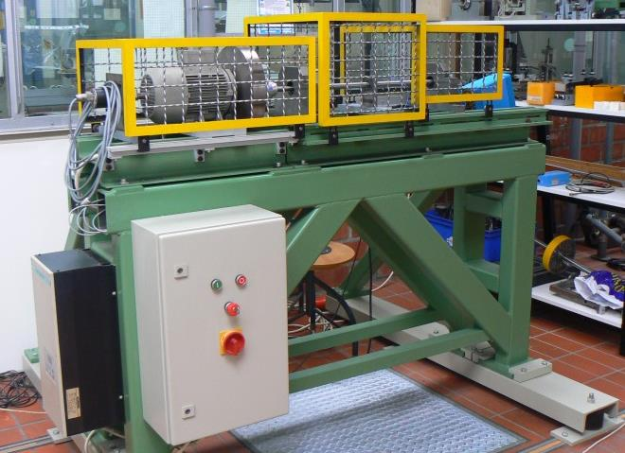

Figure 1 Test Rack

The electric motor is rotating with a defined frequency, over a coupling element the shaft is attached which is supported by two self-align bearings.To avoid frequency variations a 23kg flywheel is mounted directly on the shaft of the motor.

Between the two self-align bearings the third bearing which should be investigated is attached. The bearing is made by SKF with the bearing type number 61804. (Figure 3 and Figure 4). It is placed between a divisible bearing block.

To measure the vibrations a sensor of type PCB 353B15 will be used with a coupler of type Kistler 5134A. A measurement card of type dSPACE DS1104 with 12 Bit (A/D Converter) will be used to transmit the data to computer, so that it is possible to analyse the data with matlab. The sample frequency is fixed by 40kHz.

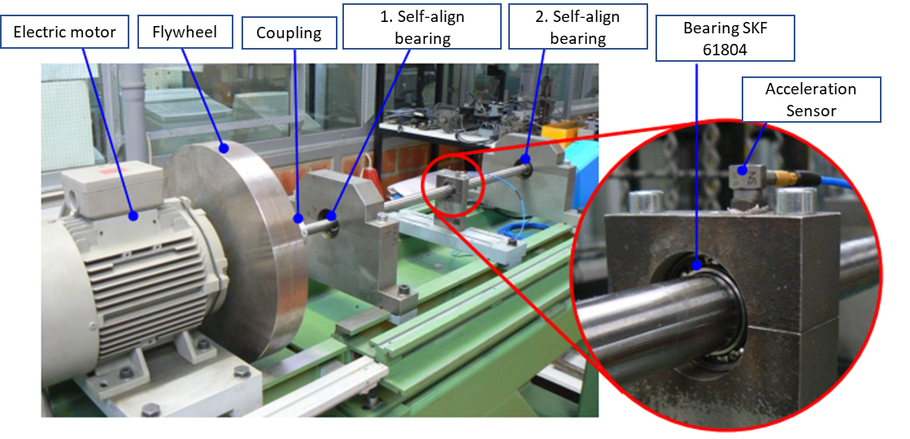

Figure 2Detailview of test rack with bearing which should be investigated.

## Geometrical data of the bearing SKF 61804

The bearing of the type SKF 61804 is a single row rill ball bearing with a cage and thirteen balls. The exact name of the bearing from the company SKF is. (SKF 61804 055C PK12).

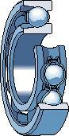

Figure 3 Single row rill bearing

Geometrical data of the bearing

|  |  |  |
| --- | --- | --- |
| nWK | 13 | (Number of rolling elements) |
| DW | 3,7mm | (Diameter of rolling elements) |
| DT | 26,15mm | (Part-circle diameter) |
| αB | 0° | (Operating contact angle) |
| fn | 50Hz | (Rotationalfrequency) |

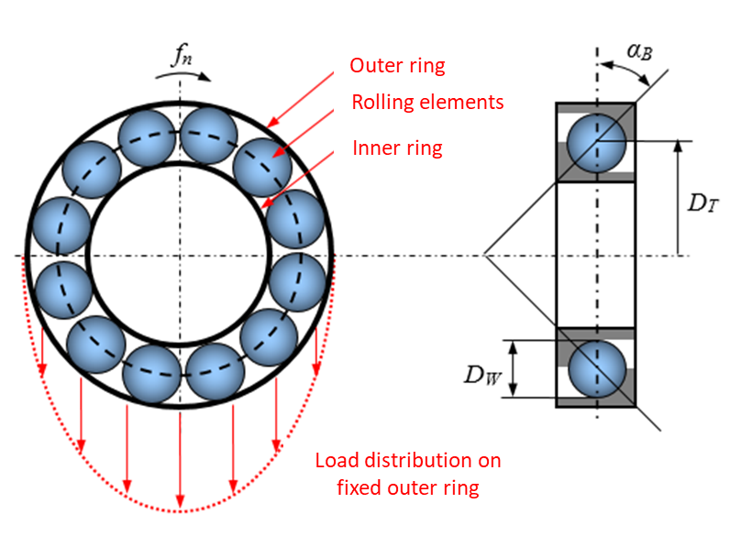

Figure 4 Geometrical data of the bearing SKF 61804

## The measurement system

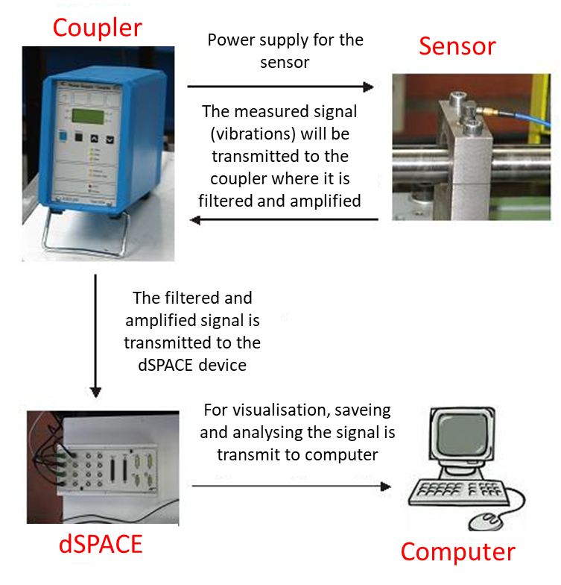

Figure measurementchain

## Data format of measurements

There are three different kinds of measurement data with the names signal1.mat, signal2.mat and signal3.mat with different states of the bearing. All datasets have the same structure.

|  |  |
| --- | --- |
| data.datensatz | Acceleration signal |
| data.fs | Sampling rate in Hz |
| data.fn | Rotational speed in Hz |
| data.comment | Descriptions of the datasets |

## Task definition

1. Analyse the three signals with different signal processing methods and determine which of the three signals is the one with the damaged bearing. Then decide which kind of damage. Different types of damage are listed in Table 1. (Use MATLAB)
2. Present your results during a short power point presentation
   * Extend: 5-10 slides
   * Duration: 10-12 minutes
   * Date: tbd.

Table Damage frequencys

|  |  |
| --- | --- |
| Cage rotational frequency with fix outer ring |  |
| Cage rotational frequency with fix inner ring |  |
| Rollover frequency of an irregularity on the outer ring |  |
| Rollover frequency of an irregularity on the inner ring |  |
| Rolling element rotation frequency or rolling element spin frequency |  |
| Rollover frequency of a rolling element irregularity on both tracks |  |

# Annotations for the analyse in frequency domain

* Please consider, that for a damaged inner ring the specific over roll frequency will be modulated by the frequency of the shaft. The result is that sidebands will occur around the damage frequency in the frequency spectrum.
* Often a damage is just detectable in higher harmonics of the over roll frequency.
* Usually bearing damages occur as shock shaped impulses. These impulses are shown as peaks, which resonate for a while because of the machine resonance. And by the damage frequency amplitude modulated signal will be detect. Aim of the envelope formation is to demodulate the signal so that just the damage frequency remains. It is a typical approach in the communication technology. A high frequency carrier signal is modulated with the message signal (Figure 6 left) to ensure an efficient transmitting. At the receiver the message signal will be separated from the modulated signal by use of the envelope formation. The envelope spectrums have the advantage compared to the power density spectrum with the original signal in time domain the visualisation of the relevant frequencies. The power density spectrum will show mainly the carrier frequency fTr. The modulation frequency fm just occur as Sidebands (figure 6, middle). By use of envelope spectrum the modulation frequency will be shown, while the unimportant carrier frequency is for example just a machine resonance.

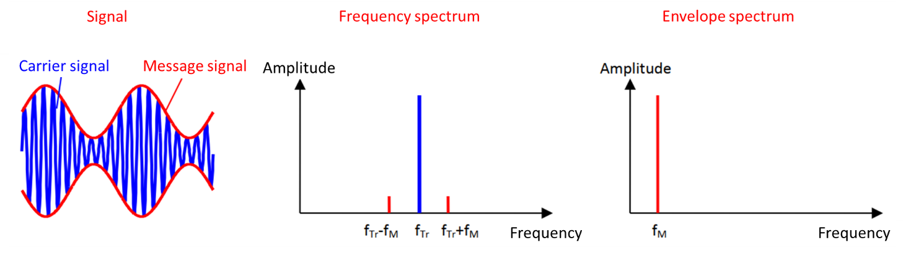

Figure 6 Comparison between frequency and envelope spectrum

The envelope can be generated using the Hilbert Transformation. The signal will be transformed to the frequency domain then phase shifted by 90° and then transformed back to time domain. The result is an analytic signal x, which real part xr is the original signal and the imaginary part xi is the Hilbert Transform:

x =xr+j ⋅xi

The amount of the analytic signal is the envelope. (Figure 7)

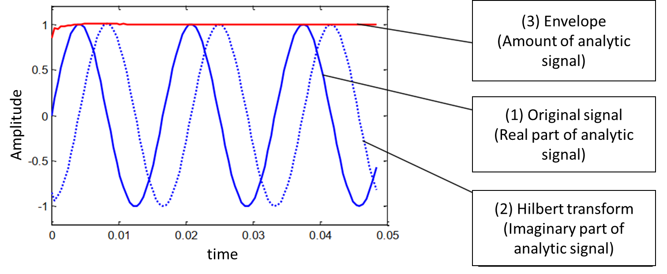

Figure 7 Creation of the envelope using Hilbert Transformation

Was the envelope extracted, the envelope spectrum can be calculated using the Fourier Transformation. Like the power spectral density, it is possible to calculate the envelope power density spectrum. Cause of simplicity it is just called envelope spectrum.

The added matlab function

[h] = hcurve_fun(y,anzeige,N)

Calculate the envelope of a time domain signal using Hilbert transformation. A description of the function is build in. (help hcurve_fun)